Expand Testing practice website- web application
User registration validation test cases (EP and BVA)

Module Name: Expand Testing practice website-user registration validation test cases
Test case ID: TC007
Platform: Web application(Responsive)
Test Technique: Equivalence Partitioning and Boundary Value Analysis

Scenario ID: 1
Scenario: EP – invalid partition (less than 3 characters)
Test steps:
- Enter username: ab (2 characters)
- Enter password: Pass@123
- Enter confirm password: Pass@123
- Click on Register

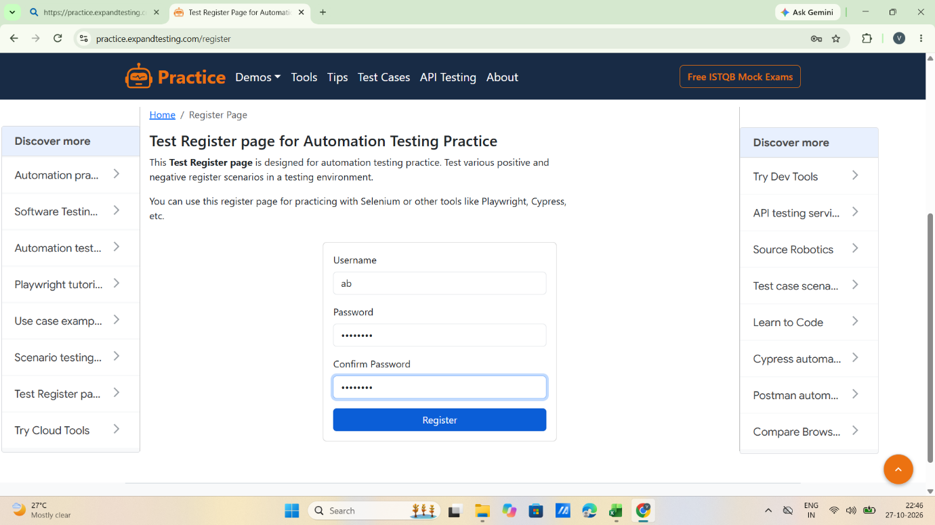

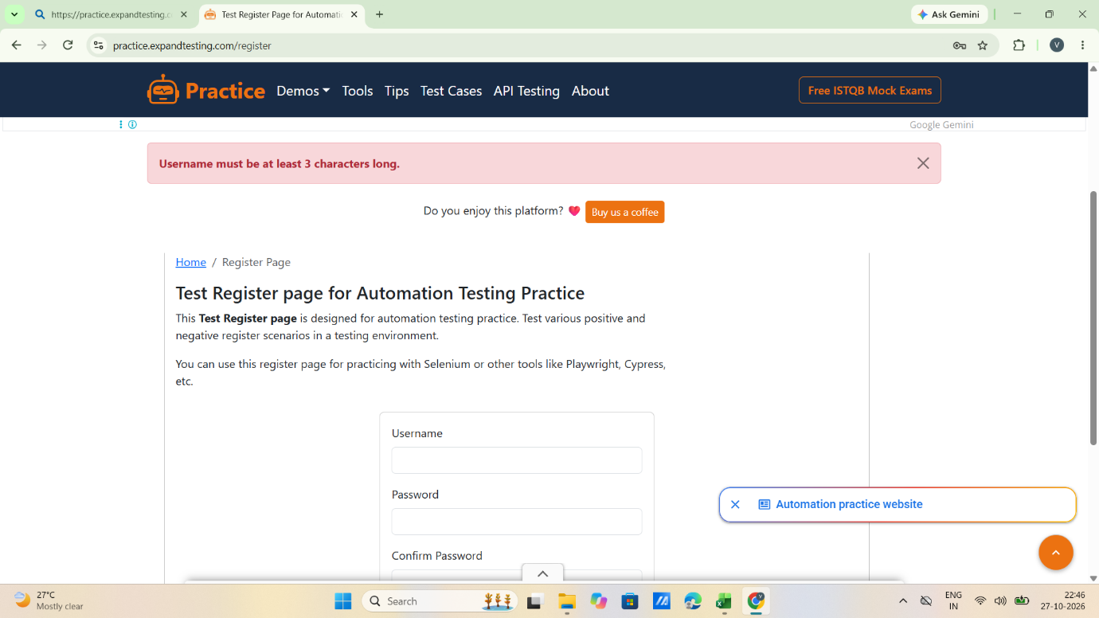

Scenario ID: 2
Scenario: EP – valid partition (3 to 39 characters)
Test steps:
- Enter username: vidhip01 (8 characters)
- Enter password: Pass@123
- Enter confirm password: Pass@123
- Click on Register

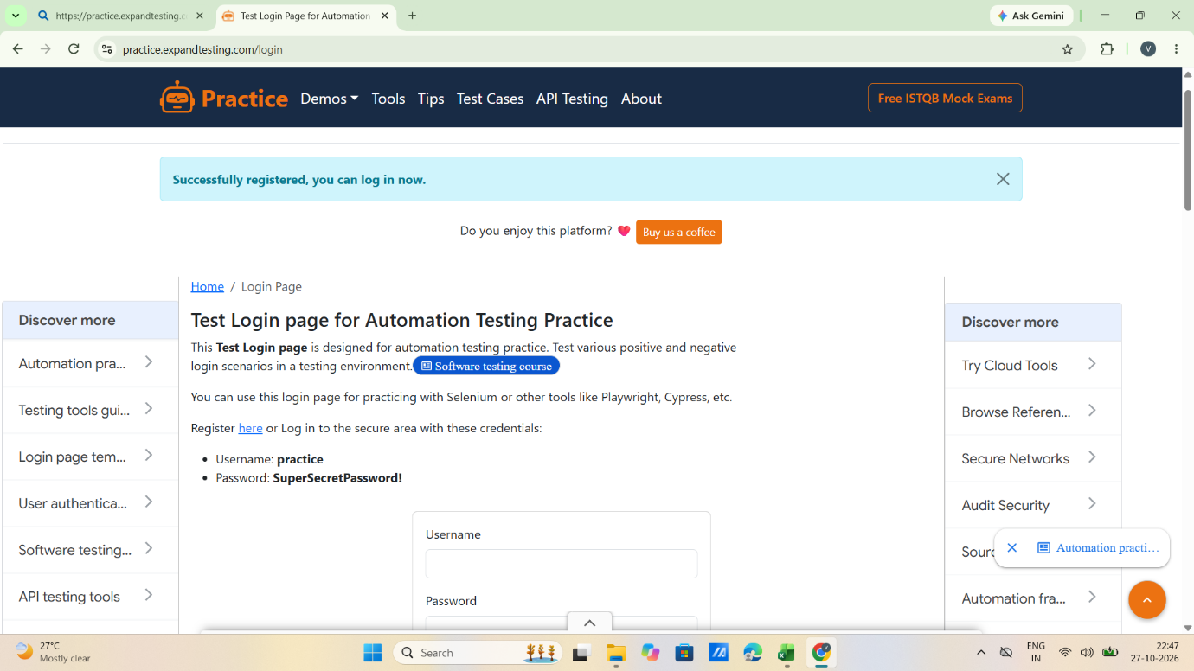

Scenario ID: 3
Scenario: EP – invalid partition (more than 39 characters)
Test steps:
- Enter username: vidhipatel912345671212345678910123456789 (40 characters)
- Enter password: Pass@123
- Enter confirm password: Pass@123
- Click on Register

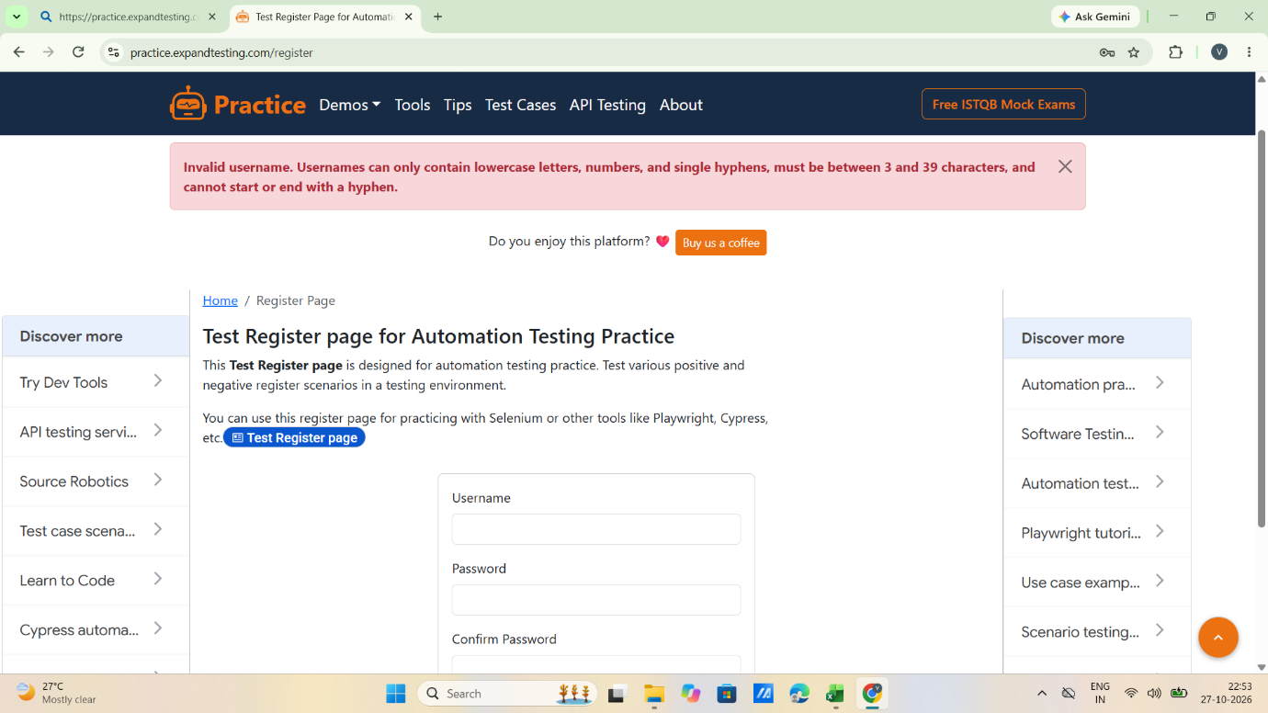

Scenario ID: 4
Scenario: BVA – Minimum − 1
Test steps:
- Enter username: vp (2 characters)
- Enter password: Pass@123
- Enter confirm password: Pass@123
- Click on Register

Scenario ID: 5
Scenario: BVA – Minimum
Test steps:
- Enter username: vp9 (3 characters)
- Enter password: Pass@123
- Enter confirm password: Pass@123
- Click on Register

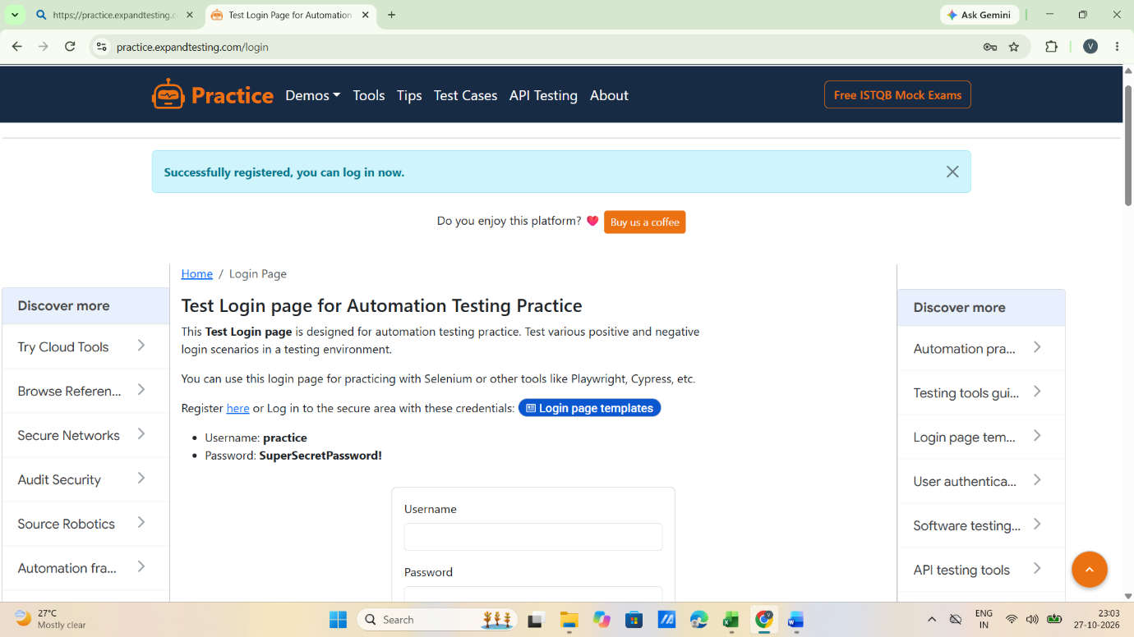

Scenario ID: 6
Scenario: BVA – Minimum + 1
Test steps:
- Enter username: vp91 (4 characters)
- Enter password: Pass@123
- Enter confirm password: Pass@123
- Click on Register

Scenario ID: 7
Scenario: BVA – Maximum − 1
Test steps:
- Enter username: vidhipatel9123456712123456789101234567 (38 characters)
- Enter password: Pass@123
- Enter confirm password: Pass@123
- Click on Register

Scenario ID: 8
Scenario: BVA – Maximum
Test steps:
- Enter username: vidhipatel912345 (39 characters)
- Enter password: Pass@123
- Enter confirm password: Pass@123
- Click on Register

Scenario ID: 9
Scenario: BVA – Maximum + 1
Test steps:
- Enter username: vidhipatel9123456712123456789101234567890(40 characters)
- Enter password: Pass@123
- Enter confirm password: Pass@123
- Click on Register

Scenario ID: 10
Scenario: Blank username
Test steps:
- Enter username: -
- Enter password: Pass@123
- Enter confirm password: Pass@123
- Click on Register

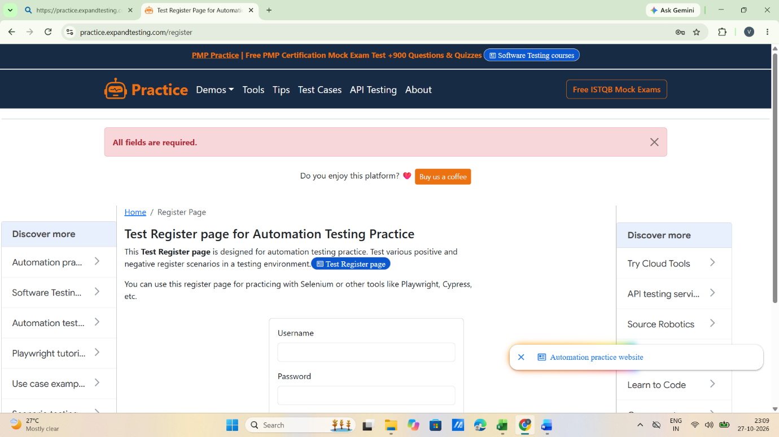

Scenario ID: 11
Scenario: Blank password
Test steps:
- Enter username: vidhip02
- Enter password: -
- Enter confirm password: -
- Click on Register

